**DAILY ONLINE ACTIVITIES SUMMARY**

|  |  |  |  |  |  |  |  |  |
| --- | --- | --- | --- | --- | --- | --- | --- | --- |
| **Date:** | **22/05/2020** | | | | | **Name:** | **Hanan Saleem Baji** | |
| **Sem & Sec** | **4th SEM 'A' Section** | | | | | **USN:** | **4AL18CS024** | |
| **Online Test Summary** | | | | | | | | |
| **Subject** | | **Operating System** | | | | | | |
| **Max. Marks** | | **30** | | **Score** | | | **22** | |
| **Certification Course Summary** | | | | | | | | |
| **Course** | **1. Python In Machine Learning** | | | | | | | |
| **Certificate Provider** | | | **1.Great Learning Academy** | | **Duration** | | | **1. 50 hours** |
| **Coding Challenges** | | | | | | | | |
| **Problem Statement: 1.** Write a c or Java program to implement round robin type of process scheduling.   1. Write C program to implement various operations on Singly Linked List Stack. 2. Write a C or a Java Program to implement FCFS and SJF process scheduling. 3. Write a program to demonstrate SRTF(Shortest remaining Time First) scheduling process. | | | | | | | | |
| **Status: completed** | | | | | | | | |
| **Uploaded the report in Github** | | | | | **yes** | | | |
| **If yes Repository name** | | | | | 1. <https://github.com/saleemhananbaji/C-coding> | | | |
| **Uploaded the report in slack** | | | | | **yes** | | | |

ONLINE TEST DETAILS: Online test was conducted on the first module of Operting System. Test contains 30 questions of 1 Mark each.

Snapshot:

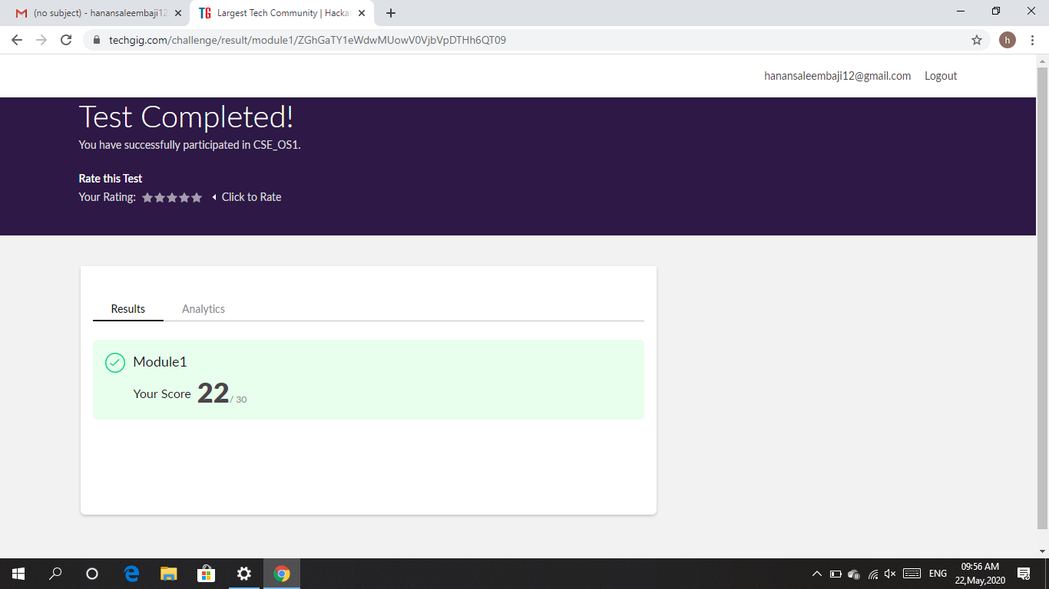

Certification Course Details: As the continuation of Python In Machine Learning certification course, I was able to complete User defined function, Lambda Functions, classes and Objects.

Snapshot: 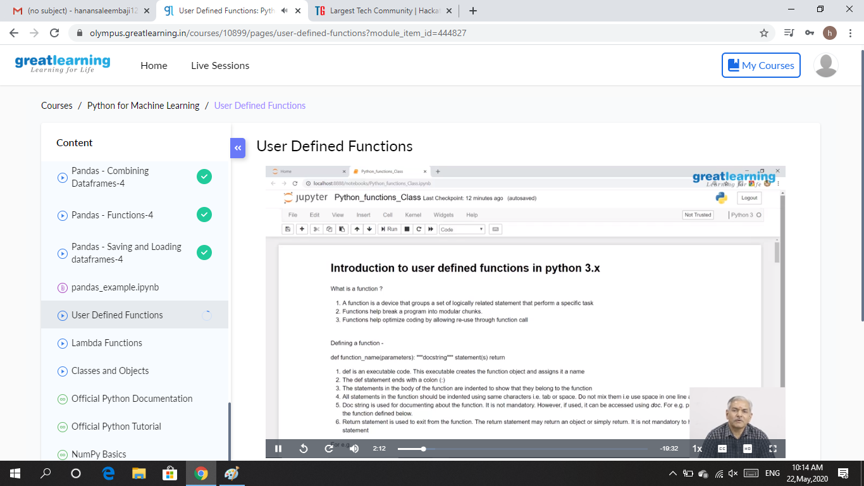

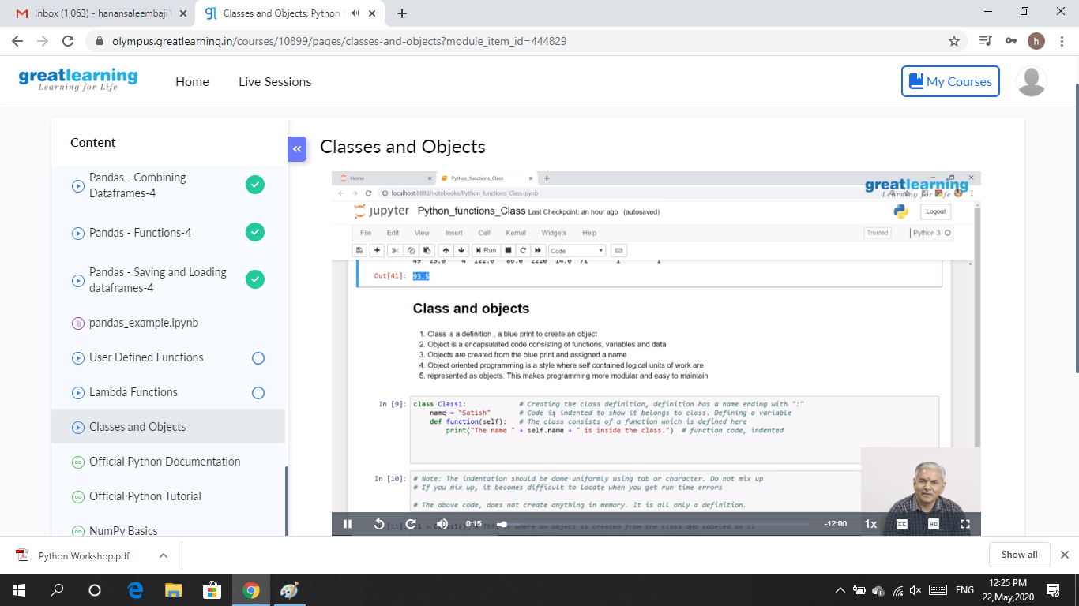

CODING CHALLENGES DETAILS: Problem statements

1. Write a c or Java program to implement round robin type of process scheduling.

Input: Process with burst time, arrival time and specify the time quantum

Output: processes scheduled based on the round robin type of scheduling, with its average waiting time.

Solution : Uploaded it in github

Snapshot:

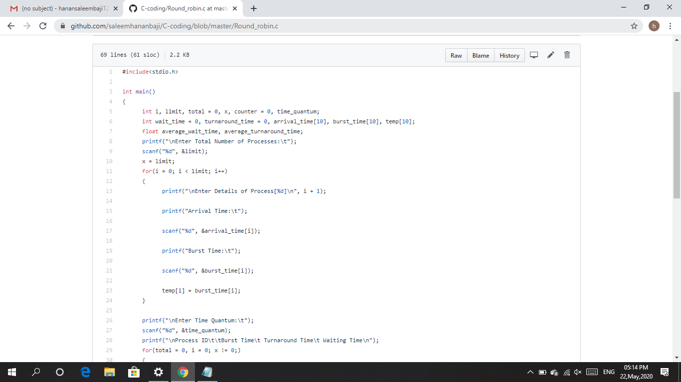

1. Write a C Program to implement various operations on Singly Linked List Stack.

Solution : Uploaded it in github

Snapshot:

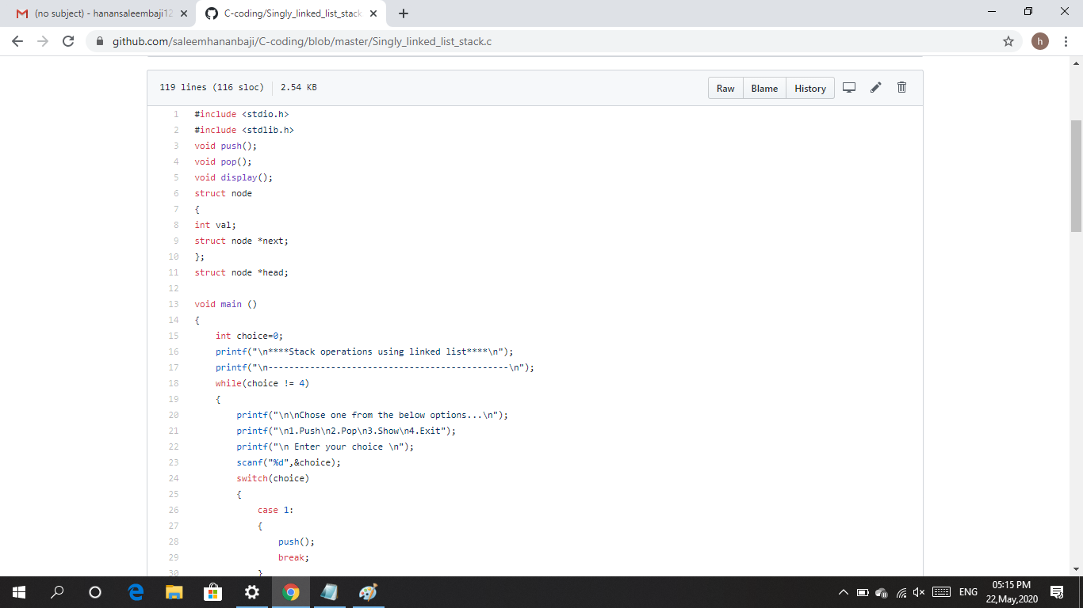

1. Write a C or Java program to implement FCFS and SJF process scheduling.

Input: Processes with burst time

Output: Process being scheduled

Solution : Uploaded it in github

Snapshot:

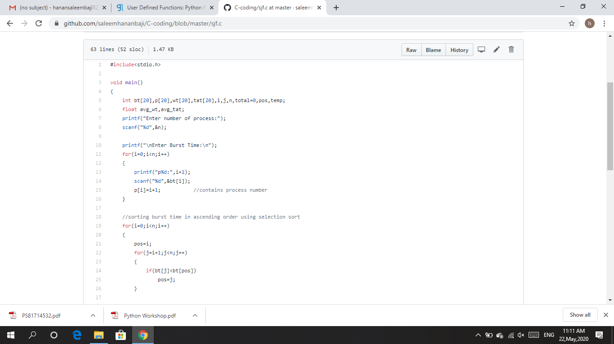

1. **Write a program to demonstrate SRTF(Shortest remaining Time First) scheduling process.**

Solution : Uploaded it in github

Snapshot:

